The Role of Rural Women in Agriculture
Written by Saquina Mucavele, MuGeDe - Women, Gender and Development, Republic of Mozambique - Southern Africa

"When women are empowered and can claim their rights and access to land, leadership, opportunities and choices, economies grow, food security is enhanced and prospects are improved for current and future generations", Michelle Bachelet - Under-Secretary-General and Executive Director of UN Women

Women are the backbone of the development of rural and national economies. They comprise 43% of the world’s agricultural labor force, which rises to 70% in some countries. In Africa, 80% of the agricultural production comes from small farmers, who are mostly rural women. Women comprise the largest percentage of the workforce in the agricultural sector, but do not have access and control over all land and productive resources. During the last ten years, many African countries have adopted new land laws in order to strengthen women’s land ownership rights. This has helped improve the situation of rural women. To this effect, the lack of appreciation of the role of rural women in agriculture is harmful and gives rise to a lack of specific policies, policies which are misdirected, high levels of poverty, illiteracy and non-involvement in the design and planning of programs and policies, which involves a process of mutual learning that reflects the real and specific needs of rural women. Despite the important roles they play in agricultural economies, rural women in Africa suffer from the highest illiteracy rates and are the most visible face of poverty. Women guarantee livelihoods, especially in rural areas. As a result of their great efforts in agricultural production, women’s production helps to guarantee their self-sustenance.
1

This is still not enough, however, to cover other needs, such as healthcare, paying for the education of their children or the acquisition of other products and goods which are necessary on a day-to-day basis since they have a limited financial capacity caused by an inefficient supply chain and poor conservation of their surpluses. Connected with these problems there is also the issue of climate change, which includes irregular rainfall, floods, droughts and cyclones, whose effects have a greater impact on rural women and make their life difficult. Rural women have to walk, moreover, long distances to carry water and fetch firewood, which is harmful for the health of humans, causing high rates of infant and maternal mortality, reversing progress in education and endangering food sovereignty, as well as food security and nutrition. Agriculture is the main alternative for Rural Women, and it should come with better access to land and resources for the prevention, adaptation and mitigation of climate change, combined with rural women learning how to deal with cultural resistance and adapting to various manifestations of this phenomenon.
Realizing the importance of rural women in agriculture is an important aspect of gender relations. In many countries, the role of women in agriculture is considered just to be a "help" and not an important economic contribution to agricultural production. Social customs dictate, moreover, that women, especially rural women, should - in addition to agricultural activities - be responsible for cooking, carrying water and fetching firewood, limiting their participation in decision-making processes and their exposure to those economic opportunities that arise, thus increasing the level of inequality vis-à-vis their partners.
Nowadays many governments tend to pay more attention to the agricultural sector than ever before.
2
More investments are, however, needed. It is a fact that rural women guarantee increases in food production. This is not, however, sufficient to meet future needs. Fighting hunger and malnutrition are some of the measures which should be taken to guarantee higher income and better living conditions for the most vulnerable communities, which are mostly formed by rural women who practice small-scale agriculture, especially in developing countries such as Mozambique. It is true that agricultural activities should lead to rural women increasing their income. Mere financial support is, however, not sufficient. The adoption of measures that facilitate the transition to a type of agriculture that respects the environment and contributes to the conservation of natural resources that benefit women is, in particular, necessary. One of the major weaknesses of the agricultural sector is to be found in the production, disposal, preservation, processing, and marketing of agricultural products.
We must undertake joint efforts to create favorable conditions in agricultural areas, including the reinforcement of road networks for the transportation of produce from production areas where rural women work, as well as the processing and commercialization of such products. There is a need to drop policies which are less favorable to rural women, focusing on the appreciation of their role as producers of wealth and strengthening the network of public services in rural areas, including health, education, and welfare services, as well as establishing policies that combat the asymmetries that prevent rural women from being protected against the effects of climate change.
3
The training of rural women is very important, especially with the adoption of modern agricultural techniques that are tailored to local conditions and that use natural resources in a sustainable manner, with a view to achieving economic development without degrading the environment. It requires the dissemination of the results of research carried out by experts - including those on agro-ecological techniques -with a view to increasing Rural Women’s production levels. To this effect, it must be pointed out that agro-ecological practices require the provision of certain public goods, such as extension services, storage facilities, rural infrastructure (roads, electricity, and information and communication technologies), access to markets and access to credit, as well as supporting organizations and farmer cooperatives. Governments have a key role to play in relation thereto, as well as supporting the access to land, water and seeds by rural women who are involved in small-scale agriculture.
3
Giving support to rural women is a way of breaking the vicious cycle that leads to rural poverty and to the expansion of slums in the cities, where the poor get poorer. Development strategies should consider rural women as the epicenter, paying special attention to their social skills both within and without agriculture sector. Policies established for the benefit of rural women should be tested and reassessed by the beneficiaries, using them as a social learning tool and not as individuals on whom political authority is exercised. Rural women - instead of being treated as mere beneficiaries – should, in other words, be viewed as experts who possess knowledge which complement experts’ formal knowledge. Participation in policies that benefit rural women can ensure truthful answers being given to this vulnerable group, since membership empowers impoverished subjects and is a vital step towards poverty alleviation.
In order to contribute to an increase in the levels of production and productivity, it is necessary to provide support to those women's organizations and farmers who promote new conceptual and development programs and who contribute to the implementation of new ideas by women with a view to diversifying income-generating activities and the provision of other services in rural areas.
4
It is extremely important to recognize the role that rural women play and the contribution that they make in networks and cooperatives, giving them greater political and financial support and involving them in the training and conducting of development programs that enhance women's role in agricultural production.
Networks operating in rural areas, especially rural women's organizations, are partners to be involved in the conception of development programs. These organizations must be aware of the local reality. To put it another way, even though global partnerships will always be necessary and useful, such organizations should work towards the empowerment of rural women since actions are always local.
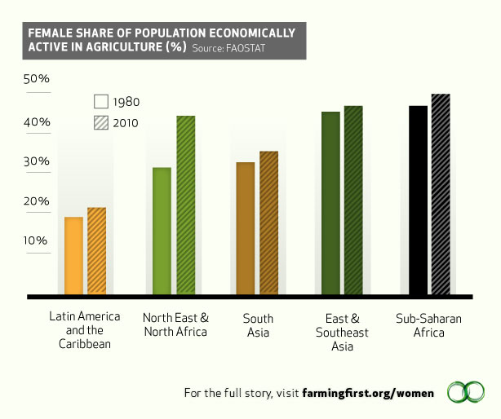
Image courtesy http://www.fao.org/gender/infographic/en/
Microfinance (also known as microloans) are playing an integral part in the role of women in the agricultural sector among the developing world. Using the chart above and background knowledge discuss the trend of women in agriculture and the accompanying effects in the developing world.
- Define microfinance (microloan).
- Identify the trend shown on the chart above.
- Despite the trend shown, explain the difficulties women are encountering in the agricultural sector.
- Discuss TWO examples of how this trend is affecting the social, political, economic, or demographic aspects of the developing world (your examples must come from DIFFERENT aspects. I.E., one from social and one from economic, etc.).

