With each statement do the following
- Graph supply and demand and label your equilibriums
- Shift either Supply or demand in the proper direction
- Tell me the reason for the shift (which part of INSECT or STRIPES)
- Tell me what happens to Price and Quantity (Make sure its labeled on the Graph)

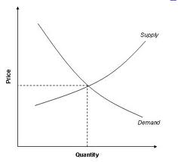
(Graph is of ice cream)

- Price of milk decreases
- Price of chocolate syrup decreases
- Workers get a 2% raise
- Consumers think that the prices of Ice Cream, are going to rise in the future
- Government taxes the production of ice cream
- Ben and Jerry’s installs new mixers
- Blue Bell closes 5 new factories
- Popsicles increase in Price
- Ice Cream cures cancer
- Population of Consumers in the US increases by 1%

