With each statement do the following
- Graph supply and demand and label your equilibriums
- Shift either Supply or demand in the proper direction
- Tell me the reason for the shift (which part of INSECT or SECRET)
- Tell me what happens to Price and Quantity (Make sure its labeled on the Graph)

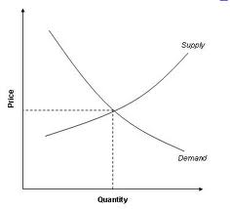
(Graph is of ice cream)

- Price of milk increases
- Price of chocolate syrup increases
- Workers take a 2% paycut
- Consumers think that the prices of Ice Cream, are going to fall in the future
- Government subsidizes the production of ice cream
- Ben and Jerry’s freezers breakdown
- Blue Bell opens 5 new factories
- Popsicles decrease in Price
- Ice Cream causes cancer
- Population of Consumers in the US decreases by 1%

