Key Issue 1: Where Are Languages Distributed?
Pages 142-149

***Always keep your key term packet out whenever you take notes from Rubenstein. As the terms come up in the text, think through the significance of the term.
- Define language:

- Define official language:

- Define language family:

- Define language branch:

- Define language group:

- Make brief notes on each of the following language families as you read about them in this section (i.e. how many people speak a language of that family, where spoken, common languages, etc.). See pages 146-149.

  - Indo-European

  - Sino-Tibetan

  - Austronesian

  - Austro-Asiatic

  - Tai Kadai

  - Japanese

  - Korean

  - Afro-Asiatic

  - Altaic

  - Uralic

  - Niger-Congo

  - Nilo-Saharan

  - Khoisan

Key Issue 2: Why is English Related to Other Languages?
Pages 150-157
- Using the reading on page 150, complete the following chart about the Germanic Language Branch
Germanic Branch
West Germanic Group | North Germanic Group
⬇  ⬇

- Indo-Iranian Branch: Make 2 bullets charts from the reading.
Indic Group (Eastern) | Iranian Group (Western)

- How did Russian become the most important East Slavic language?

- What is the most important West Slavic language?

- Describe the controversy between Czech and Slovak languages under Czechoslovakia’s government? What happened?

- Why are South Slavic languages, which were once very similar to each other, becoming increasingly different today?

- The four most contemporary Romance languages are _________________________, ________________________, _________________________ & ______________________________.

- How did English become widely diffused?

- What three European people originally came together to form the English people and English language?

- Where did these people come from?

- What two subsequent invasions added additional words to the evolving English language?

- When and why did English diffuse to North America?

- How did Latin languages diffuse in Europe? What happened to the native languages?

- Define Vulgar Latin:

- What is the name of the (theoretical) common ancestral language of all languages discussed in this key issue of the chapter?

- Why is its existence difficult (impossible) to prove?

- Contrast the two views of the origin of this language in the chart below.

“Kurgan” Theory | Renfrew Hypothesis

Key Issue 3: Why Do Individual Languages Vary Among Places?
Pages 158-163

- Dialects are defined as “regional variations of a language” and are distinguished by three things. What are they?

- Explain what an isogloss is.

- People from all three eastern regions (New England, Southeastern, Midlands) migrated into the Midwest, Great Plains and Western United States. Why is there a relatively uniform form of English (dialect) spoken across this enormous area?

- Define standard language:

- What is the standard language for of English? Where did it come from (3 cities)? How was it diffused throughout Britain?

- In a single word, why is American English different from that spoken in England?

- Why don’t people in the United States speak “proper” English?

- Why is it that nearly 90% of Spanish & Portuguese speakers live outside of Europe?

- Why is it difficult to distinguish individual languages from dialects?

- Define creolized language:

Key Issue 4: Why do People Preserve Local Languages?
Pages 164-177
- Prepare detailed notes with bullets and notations on the maps regarding the following case studies:
- Belgium: Political & linguistic divides (Figure 5-27)
Switzerland: Peace in a multi-lingual state (Figure 5-29)
Nigeria: Problems in a multi-lingual state (Figure 5-30)

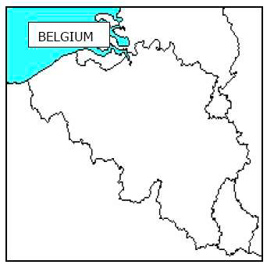
Notes:

Notes:

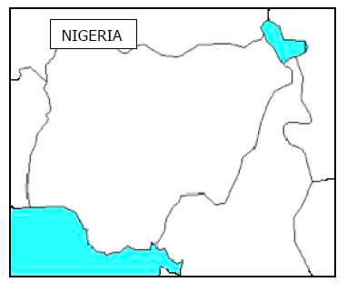
Notes:

- Complete the chart below by taking notes on the various languages/countries & the issues they are facing.
Basque –

Icelandic –

Native American –

Hebrew –

Celtic- (Welsh, Irish, Breton, Scottish, Cornish)

Australia-

New Zealand-

Occitan-

- Define lingua franca:

- Define pidgin language:

- How has expansion diffusion occurred with English? Give three examples.

- Does the United States have an official language? Why or why not?

- Discuss how the French language is important in Canada.

- Why is much of the internet in English? Why might this be problematic?

