**Key Issue 1: Where is the World’s Population Distributed?**

***Pages 45-49***

*\*\*\*Always keep your key term packet out whenever you take notes from Rubenstein. As the terms come up in the text, think through the significance of the term.*

1. 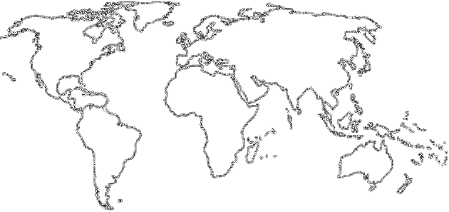The world’s population is highly clustered, or concentrated in certain regions. FOUR major population concentrations are identified in the text. **Shade** and **label** the areas of these concentrations on the map in **red**. TWO smaller concentrations, or emerging clusters, are also identified. **Shade** and **label** these areas on the map in **blue**.
2. In the boxes below, make note of significant facts, features, countries involved, and characteristics of the **four** most important population concentrations and **two** secondary ones.

|  |  |  |  |
| --- | --- | --- | --- |
| **EAST ASIA** | | **SOUTH ASIA** | |
| **SOUTHEAST ASIA** | **EUROPE** | | **EASTERN NORTH AMERICA**  **WEST AFRICA** |

1. Define ***ecumene:***
2. What would ***non-ecumene*** mean?
3. In the table below, list the four “lands” which are sparsely populated on earth. For each region, explain the reason which makes it inhospitable for human habitation.

|  |  |
| --- | --- |
| **Sparsely Populated Land** | **Reason(s) for Inhospitality** |
| Dry Lands |  |
| Wet Lands |  |
| Cold Lands |  |
| High Lands |  |

1. Use the maps on page 47 to prepare a sketch map that shows **non-ecumene** and **very sparsely inhabited lands.**
2. Define ***arithmetic density:***
3. Define ***physiological density:***
4. What occurs when the rate of physiological density increases?
5. Define ***agricultural density:***

**Key Issue 2: Why Is Global Population Increasing?**

***Pages 50-55***

1. Define ***crude birth rate (CBR)***:
2. Define ***crude death rate (CDR)***:
3. Define ***natural increase rate (NIR)***:
4. What is the NIR today?
5. When did the global NIR peak, and what was it?
6. About how many people are being added to the world’s population each year?
7. Define ***doubling time:***
8. In what world regions is most growth occurring?
9. Define ***total fertility rate (TFR)****:*
10. What is the global “average” TFR?
11. Note the rates and locations of the global “highs and lows” in TFR.
12. The shape of a pyramid is primarily determined by what demographic rate?
13. What is the ***dependency ratio?***
14. What age groups are categorized as **“dependent”**?
15. What does the **“graying”** of a population refer to?
16. What is the ***sex ratio****?*
17. What types of countries/regions are likely to have more males than females? Why?

**Key Issue 3: Why Does Population Growth Vary Among Regions?**

***Pages 56-63***

***\* This is an ESSENTIAL KEY ISSUE!!!! You will be required to draw and explain the DTM!!!!! You will also need to be able to read population pyramids and connect them to stages of the DTM!\****

1. The **demographic transition** is a ________________________ with several

___________________ and every __________________________ is in one of the stages.

1. Fill in the chart below with characteristics describing each stage in the demographic transition model (CBR, CDR, NIR, etc.). Characterize the amount of growth of each stage (low, high, decreasing (aka moderate) etc.).

|  |  |  |  |
| --- | --- | --- | --- |
| **Demographic Transition Model** | | | |
| Stage 1 | Stage 2 | Stage 3 | Stage 4 |
|  |  |  |  |

1. In the chart below, which represents the four stages of demographic transition, identify the country and where it is located which is in that stage and briefly describe how it got to that stage. Use the DTM samples and population pyramids on pages 56-57 to help you with this.

|  |  |  |  |
| --- | --- | --- | --- |
| **Stages of the Demographic Transition Model** | | | |
| Stage 1 | Stage 2 | Stage 3 | Stage 4 |
| No country in stage 1 |  |  |  |

1. How many countries are in each of the following stages of demographic transition?
   1. Stage 1?
   2. Stages 2 and 3?
   3. Stage 4?
2. In what sense can we say that the first break came to **different world regions** for **different reasons** and in **different ways**?
   1. It came to Europe and North America…
   2. It came to Africa, Asia, and Latin America…
3. The CBR has declined rapidly since 1990. **Identify** the **two** strategies that have been successful in reducing birth rates and **explain** **why** they have been successful.



1. Complete the table below to describe the views/theories of various population theorists:

|  |  |  |
| --- | --- | --- |
| Thomas Malthus | Neo-Malthusians | Critics of Malthus |
|  |  |  |

1. Where has Malthus’s theory proven right?
2. In what ways was Malthus mistaken?
3. Examine Japan’s population:
   1. How is Japan’s population expected to change by 2050?
   2. Why is this expected to happen?
   3. Why is it problematic for Japan?
4. Identify the two “**big breaks”** in the demographic transition and their **causes**.
   1. The first break…
   2. The second break…
5. What would characterize a possible stage 5 of the DTM?
6. In the chart below, summarize/bullet key points of India’s and China’s population policies

|  |  |
| --- | --- |
| **India** | **China** |
|  |  |

**Key Issue 4: Why Do Some Regions Face Health Threats?**

***Pages 64-73***

1. What is ***epidemiologic transition?***
2. Complete the table below with notes on the stages of epidemiologic transition:

|  |  |  |  |  |
| --- | --- | --- | --- | --- |
| **Stage 1** | **Stage 2** | **Stage 3** | **Stage 4** | **Possible Stage 5** |
|  |  |  |  |  |

1. Two important indicators of health in a country are infant mortality rate (IMR) and life expectancy.
   1. Define ***infant mortality rate:***
   2. Define ***life expectancy:***
2. How are these mortality rates distributed globally, in terms of the developed and developing worlds?
3. Compare and contrast reasons for variations in health care between developed and developing countries.