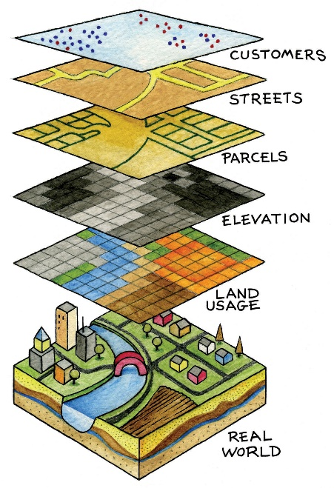

**Navigate to Google and search “National Geographic Map Maker” (**[**http://mapmaker.nationalgeographic.org/#/**](http://mapmaker.nationalgeographic.org/#/)**)**

**Goal:** This activity will allow you to utilize the National Geographic Map Maker application to learn about GIS (Geographic Information Systems). GIS allows for the layering of data to understand patterns and relationships. Please report your data on a separate sheet of paper.

1. Click on “Add Layer”>”Food”>”Rice Production”>Click on “+” sign>”Done”>”Legend”
   1. Who are several of the top rice producers in the world?
2. Keep that layer for a moment and place a pin on the top rice producers. Do so by clicking on the left tool bar (“Draw a marker”) and placing it on the countries who produce the greatest amount of rice.
3. Remove that layer by clicking on the “Layers” tab and clicking the “x” on the layer. Your pins should still be present.
4. Add another layer. This time add the layer of “undernourishment” also under the “food” category.
   1. Which regions are most undernourished?
   2. Are the top rice producers (those that you pinned) also undernourished? Which are? Which aren’t?
5. Retain the “undernourishment” layer. Add the “Gross National Income per Capita” layer. Set the “undernourishment” layer to approximately 100% transparency. Set the “Gross National…” layer to 50% transparency. Make sure GNI is the top layer and undernourishment is the bottom.
   1. Define Gross National Income per Capita (look at where you select this layer for a description or Google)
   2. What is the connection between Gross National Income and undernourishment?
6. Remove all current data by clicking “reset map.”
7. Add the “Climate Zone” layer by looking under the “Climate and Weather” category.
   1. What kind of thematic map is this?
   2. What zone is Orlando located in (make sure you view the legend to determine this)?
8. Remove the current layer and add the “African American Population (1960)” layer under the “U.S. History” category.
   1. What regions in the United States are African Americans clustered in?
9. Retain the previous layer and add the “Major Religions” layer under “Culture.” Make sure the African American population layer is on the top and set at approximately 50% transparency. Set the “religions” layer at 100%.
   1. What major religion are African Americans predominately affiliated with?
   2. What religion is most common in the north east and Great Lakes region?
10. Remove all current data by clicking “reset map.”
11. Add the “Women in Parliament” layer. “Parliament” refers to the fact that these women are in significant leadership roles in their country and are responsible for creating legislation (laws)
    1. Does Mexico have more/ less women in parliament than the U.S.?
    2. What regions have the most?
    3. What regions have the least?
    4. What regions surprised you?
12. Remove all current data by clicking “reset map.”
13. Add the layer “Lights At Night” under the “Human Systems” category
    1. Which areas are the brightest?
    2. Which areas are the darkest?
14. Retain the current layer and add the layer “Population Density” also under the “Human Systems” category. Make sure the “Lights at Night” is first and set the transparency to approximately 50%. Set the transparency of the pop. density layer to 100%.
    1. Explain the correlation (mutual relationship between two or more things).
    2. Does the correlation hold true for all areas of the world?

________________________________

GIS (Geographic Information Systems)