Name: ____________________________________ Period: _________
AP Human Geography: Agriculture Mapping
With this you will be identifying key agricultural terms and their geographic regions. You will use maps in your textbook or online to be able to identify and color these places. In some cases regions will overlap and you will have to look at a variety of maps to find the best summary of information. Maps need to be colored neatly with keys that are properly labelled.

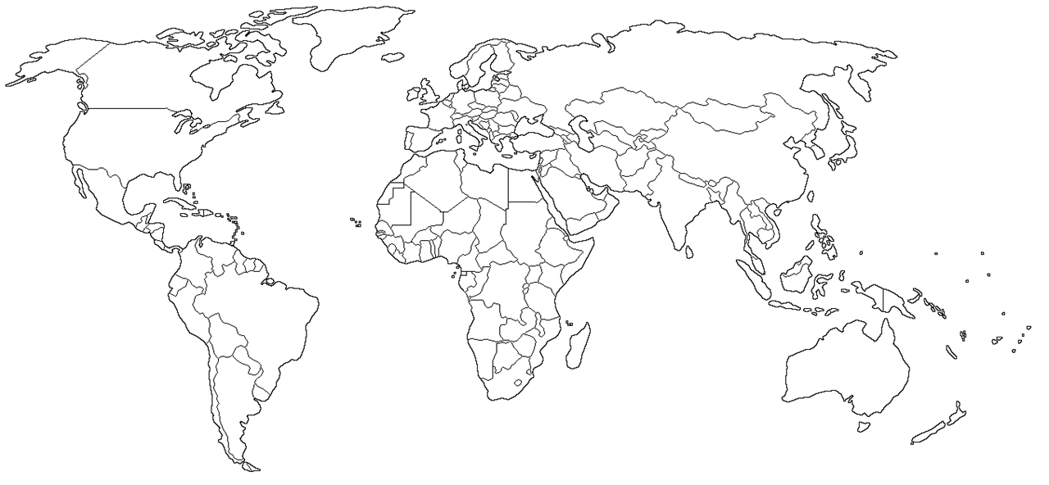
MAP 1 – CLIMATE ZONES
KEY

MAP 2 – PRECIPITATION LEVELS
KEY

MAP 3 – AGRICULTURAL HEARTHS
Identification on Map | Hearth | Major Crop(s) | Animals
Southwest Asia
(Fertile Crescent)
 | Southeast Asia
 | Americas
 | Africa
MAP 4 – AGRICULTURAL TYPES
Commercial Agriculture |  | Subsistence Agriculture
 |  |  | X
Map 5 – Agricultural Belts: Corn, Fruit, Ranching, Dairy, Wheat, Specialty Crops (Citrus, etc.)
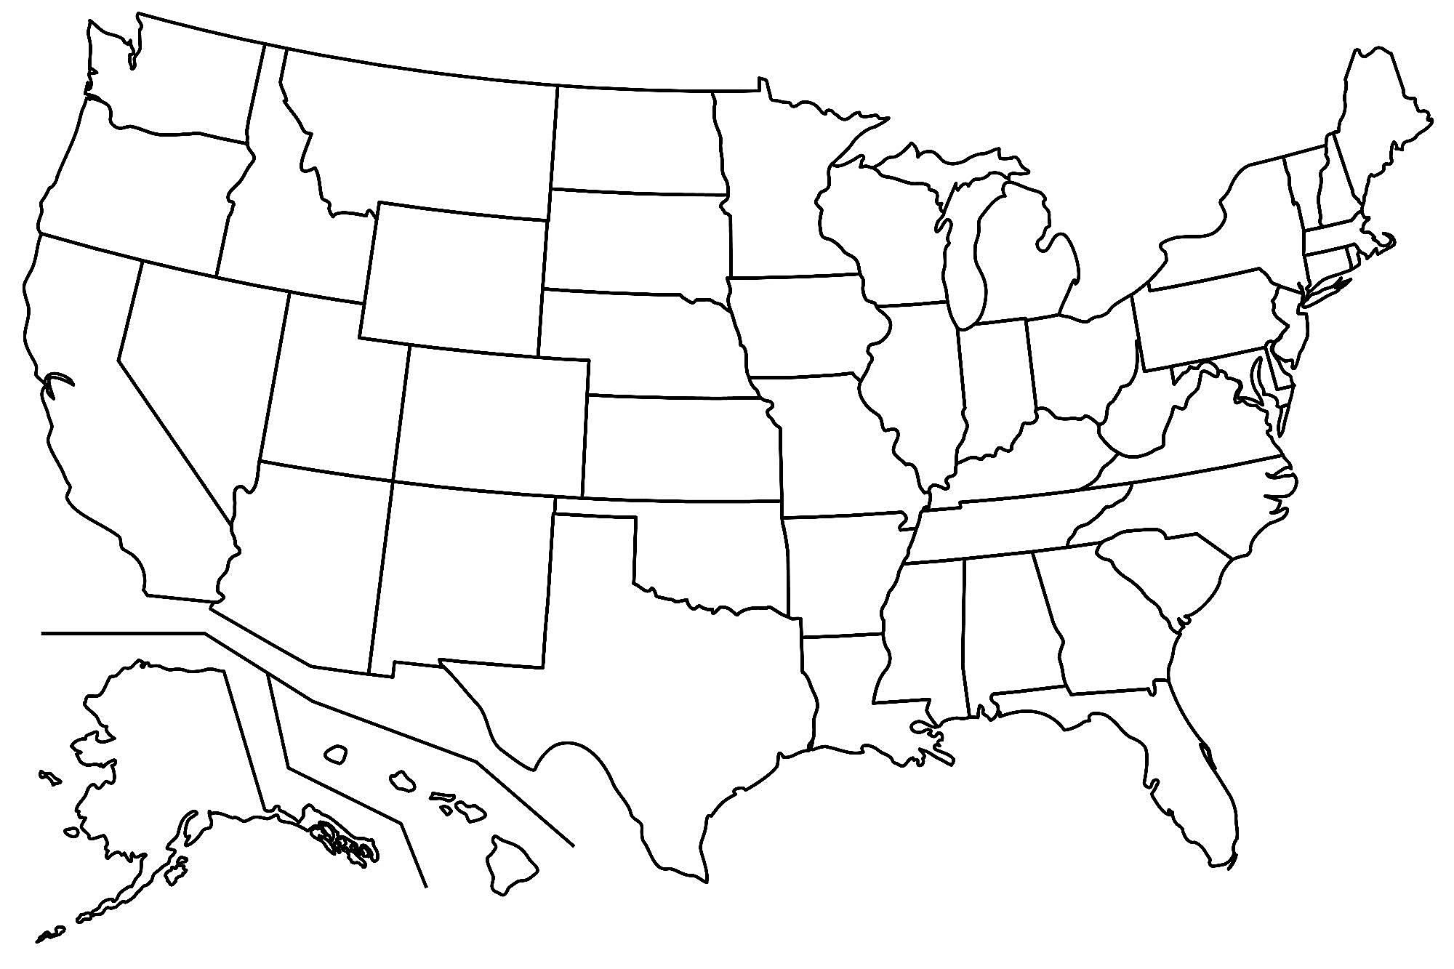
KEY

